# Conceptual

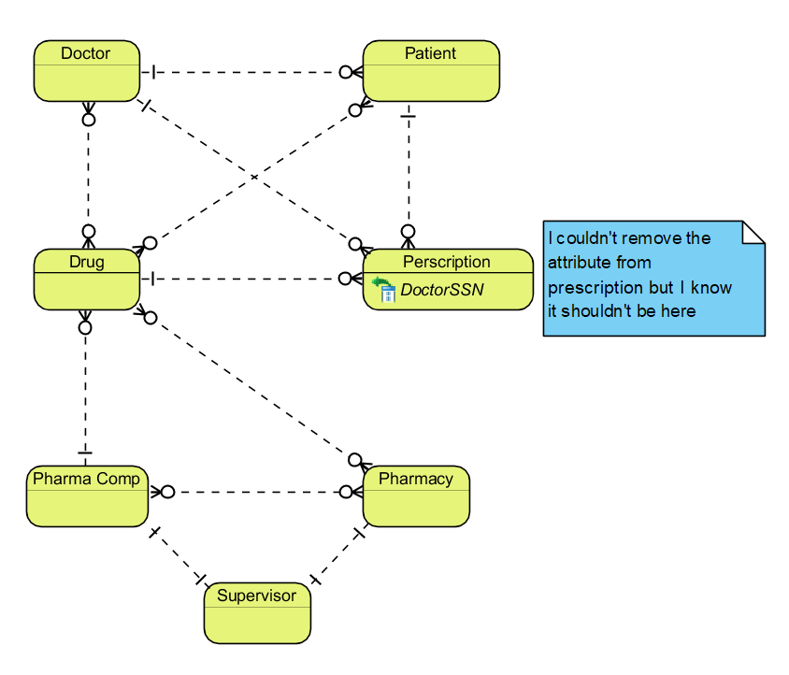

# ERD

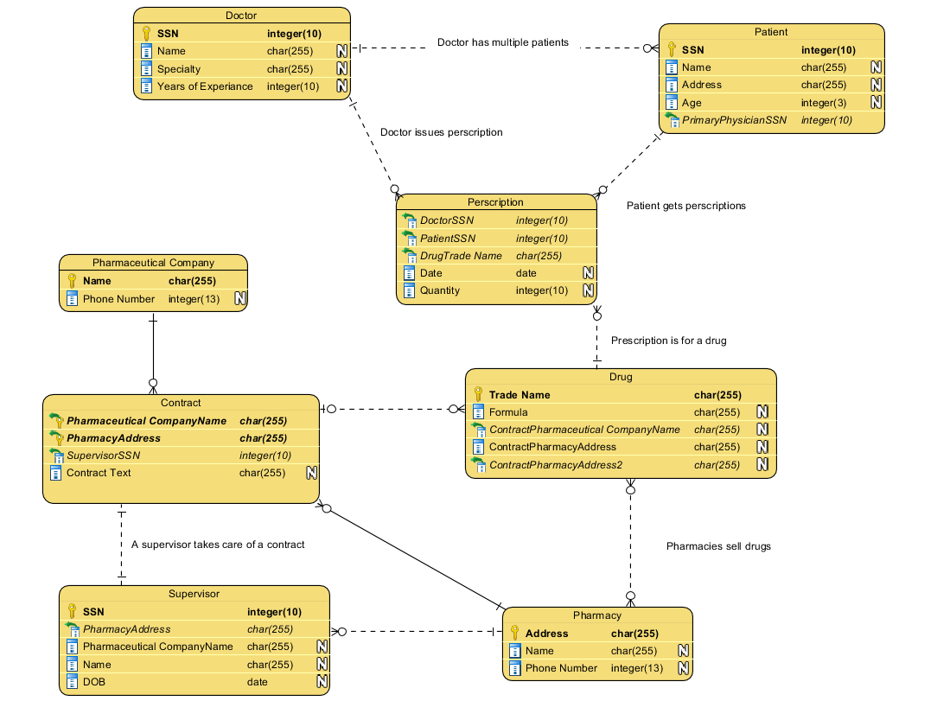

# Relational Database Schema

Customer(customerID, lastName, firstName, address, city, state, zip, phone)

SalesPerson(salesPersonID, salespersonFirstName, salespersonLastName, salespersonCode)

Sales_Order(salesordernumber, date, subtotal, tax, total, customerID, salespersonID)

Sales_Order(customerID) is a foreign key in reference to Customer(customerID), and Sales_Order(salespersonID) is a foreign key reference to SalesPerson(salespersonID).

Item(itemnumber, unitprice, description)

Order_Line_Item(lineNumber, salesordernumber, quantity, unitprice, extenedPrice, itemnumber)

Order_Line_Item(salesordernumber) is a foreign key reference to Sales_Order(salesordernumber), and Order_Line_Item(itemnumber) is a reference to Item(itemnumber)

# SQL

1. update room set price = price * 1.05;



1. select * from room where type = "family" or type = "double" and price < 40 ORDER BY price ASC;

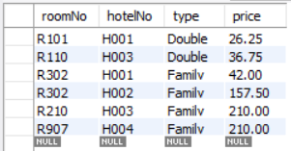

1. SELECT sum(price)/count(price) FROM room;



1. select * from room where roomNo not in (select roomNo from booking);

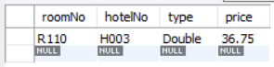

1. select hotelNo, count(roomNo) from room where hotelNo in (select hotelNo from hotel where city = 'Washington');



1. select * from booking where dateTo is null or dateTo = '0000-00-00';

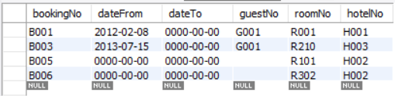

1. select * from hotel where city = 'London';



1. select count(hotelNo) from hotel;



1. select sum(price) from room where type = 'Double';



1. truncate table booking; // it says 0 rows affected but works nevertheless



# Transaction

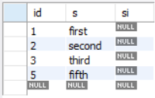

The “ROLLBACK” command took effect on the fourth element because it was preceded by “START TRANSACTION”. MySQL then went back int auto-commit mode, which is why the last rollback did not work.